Exercise 5: REST - Get country based on country code

Write a REST service that returns a specific country based on country code. The country code should be case insensitive.

Controller: com.cognizant.spring-learn.controller.CountryController
Method Annotation: @GetMapping("/countries/{code}")
Method Name: getCountry(String code)
Method Implemetation: Invoke countryService.getCountry(code)
Service Method: com.cognizant.spring-learn.service.CountryService.getCountry(String code)

Service Method Implementation:
Get the country code using @PathVariable
Get country list from country.xml
Iterate through the country list
Make a case insensitive matching of country code and return the country.
Lambda expression can also be used instead of iterating the country list
Sample Request: http://localhost:8083/country/in

Sample Response:
{
"code": "IN",
"name": "India"
}
Program:
Country.java:
package com.cognizant.springlearn.model;

public class Country {
private String code;
private String name;

public Country() {}

public Country(String code, String name) {
this.code = code;
this.name = name;
}

public String getCode() {
return code;
}

public void setCode(String code) {
this.code = code;
}

public String getName() {
return name;
}

public void setName(String name) {
this.name = name;
}

@Override
public String toString() {
return "Country [code=" + code + ", name=" + name + "]";
}
}
CountryService.java:
package com.cognizant.springlearn.service;

import com.cognizant.springlearn.model.Country;
import org.springframework.stereotype.Service;

import java.util.ArrayList;
import java.util.List;

@Service
public class CountryService {

private static List<Country> countryList = new ArrayList<>();

static {
countryList.add(new Country("IN", "India"));
countryList.add(new Country("US", "United States"));
countryList.add(new Country("DE", "Germany"));
countryList.add(new Country("JP", "Japan"));
}

public Country getCountry(String code) {
return countryList.stream()
.filter(c -> c.getCode().equalsIgnoreCase(code))
.findFirst()
.orElse(null);
}
}
CountryController.java:
package com.cognizant.springlearn.controller;

import com.cognizant.springlearn.model.Country;
import com.cognizant.springlearn.service.CountryService;
import org.slf4j.Logger;
import org.slf4j.LoggerFactory;
import org.springframework.beans.factory.annotation.Autowired;
import org.springframework.web.bind.annotation.*;

@RestController
public class CountryController {

private static final Logger LOGGER = LoggerFactory.getLogger(CountryController.class);

@Autowired
private CountryService countryService;

@GetMapping("/countries/{code}")
public Country getCountry(@PathVariable String code) {
LOGGER.info("START - getCountry()");
Country country = countryService.getCountry(code);
LOGGER.info("END - getCountry()");
return country;
}
}

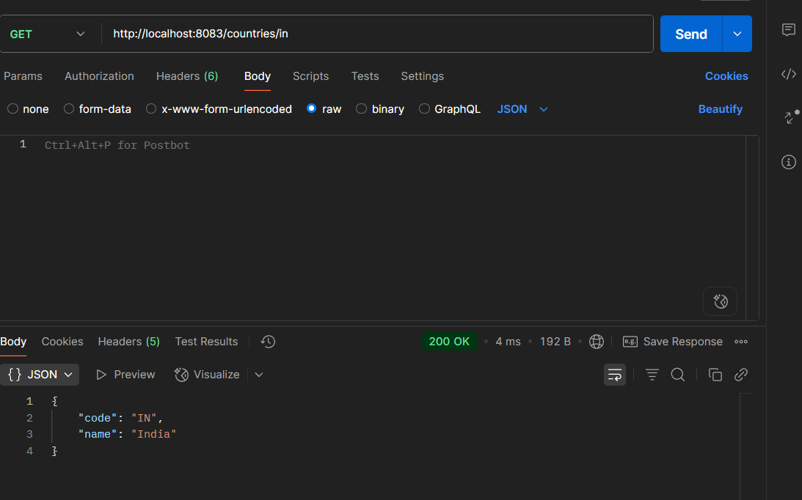
Application.properties:
server.port=8083
Output:
